Dropbox
(Cloud File Storage)
- What is this system and why is this used?
  - Cloud file storage enables users to store their data on remote servers. Usually, these servers are maintained by cloud storage providers and made available to users over a network (typically through the Internet). Users pay for their cloud data storage on a monthly basis.
  - Cloud file storage services have become very popular recently as they simplify the storage and exchange of digital resources among multiple devices. The shift from using single personal computers to using multiple devices with different platforms and operating systems such as smartphones and tablets each with portable access from various geographical locations at any time, is believed to be accountable for the huge popularity of cloud storage services.
  - Following are some of the top benefits of such services:
    - Availability: The motto of cloud storage services is to have data availability anywhere, anytime. Users can access their files/photos from any device whenever and wherever they like.
    - Reliability and Durability: Another benefit of cloud storage is that it offers 100% reliability and durability of data. Cloud storage ensures that users will never lose their data by keeping multiple copies of the data stored on different geographically located servers.
    - Scalability: Users will never have to worry about getting out of storage space. With cloud storage you have unlimited storage as long as you are ready to pay for it.
  - abc
- Goals and Requirements of the system:
  - functional requirements
    - Users should be able to upload and download their files/photos from any device.
    - Users should be able to share files or folders with other users.
    - Our service should support automatic synchronization between devices, i.e., after updating a file on one device, it should get synchronized on all devices.
    - The system should support storing large files up to a GB.
    - Our system should support offline editing. Users should be able to add/delete/modify files while offline, and as soon as they come online, all their changes should be synced to the remote servers and other online devices.
  - non-functional requirements
    - ACID-ity is required. Atomicity, Consistency, Isolation and Durability of all file operations should be guaranteed.
  - extended requirements
    - The system should support snapshotting of the data, so that users can go back to any version of the files.
- Workflow:
The user will specify a folder as the workspace on their device. Any file/photo/folder placed in this folder will be uploaded to the cloud, and whenever a file is modified or deleted, it will be reflected in the same way in the cloud storage. The user can specify similar workspaces on all their devices and any modification done on one device will be propagated to all other devices to have the same view of the workspace everywhere.
- Nature of business:
  - What type of tinyurl do we need?
The tiny url will have two parts: one will be domain name and the other will be random value appended to that. As in the tiny url service, we try to make the url as small as possible. So we try to purchase domain name as small as possible.
  - some of the features need to be faster than the others,
Read should be faster than write.
  - some of the features can be used more than the others during some specific time,
Any shortUrl published on facebook or twitter will be used very large number of times in first two hours and after that no-one will care about that.
  - some of the features can be used more than the others from some specific geolocation,
Any shortUrl published on facebook or twitter will be used mostly by the users of that country or geolocation so CDN will help much in our case.
- Type of users:
  - Public users,
There will be public users who will be able to create public tiny urls.
  - Private users,
    - The private users will be able to generate private tiny urls as well which could only be accessed by the certain set of users.
    - The private users will be able to generate customTinyUrls.
  - Admin user,
The informations extracted from analytics data should be provided to the admin user on the dashboard and he should be able to change the settings and configuration of the site.
- Some Design Considerations,
  - We should expect huge read and write volumes.
  - Read to write ratio is expected to be nearly the same.
  - Internally, files can be stored in small parts or chunks (say 4MB); this can provide a lot of benefits i.e. all failed operations shall only be retried for smaller parts of a file. If a user fails to upload a file, then only the failing chunk will be retried.
  - We can reduce the amount of data exchange by transferring updated chunks only.
  - By removing duplicate chunks, we can save storage space and bandwidth usage.
  - Keeping a local copy of the metadata (file name, size, etc.) with the client can save us a lot of round trips to the server.
  - For small changes, clients can intelligently upload the diffs instead of the whole chunk.
- UI:
- System APIs,
  - system APIs,
We can have SOAP or REST APIs to expose the functionality of our service:
createTinyUrl(String longUrl, long expirationTime = null); // returns tinyUrl
getLongUrl(String tinyUrl);
delete api can also be there to delete the short url on demand.
  - Security and permissions means how to detect and prevent abuse?
    - We will need to have different rate limits for different apis. For example, allowed tinyUrlGeneration limit should be less than allowed tinyUrlRead limit.
    - Public users who are accessing the APIs, they should be identified by their IPs, mac address, temporaryUserSessionToken, etc. and they should not be allowed to create tinyUrls at more than allowed rate, means their should be some check on the rate of creation and accessing of tinyUrls by single user to stop the DOS attack. This setting is done generally on load balancer.
    - Private and registered users can have permissions to create and get more tinyUrls.
- Capacity Estimation and Constraints: Estimation will help us understand our system better.
We will apply 30 : 50 : 70 capacity model for bandwidth, memory and storage.
  - Estimate of number of users and their uses,
    - Let’s assume that we have 500M total users, and 100M daily active users (DAU). Let’s also assume that 1 million users are active at any time.
    - Let’s assume that on average each user connects from three different devices.
    - On average if a user has 200 files/photos, we will have 100 billion total files.
  - Estimate of read and write ratio,
As we have estimated that on average each user connects from three different devices, so write from any one device will be replicated on the other two devices. So our write and read ratio will be 1 : 2.
  - Storage estimates,
Let’s assume that average file size is 100KB, this would give us ten petabytes of total storage.
100B * 100KB => 10PB
  - Traffic estimates,
  - Bandwidth estimates,
  - Memory estimates,
- Database design,
  - Important points about nature of data,
A few observations about the nature of the data we will store:
    - We need to store billions of records.
    - Each object we store is small (less than 1K).
    - There are no relationships between records—other than storing which user created a URL.
    - Our service is read-heavy.
  - Basic database schema,
    - userTable(userId, email, name, creationDate, lastLogin)
    - urlMapTable(tinyUrl, originalUrl, creationDate, expirationDate, userId)
  - identify the relations,
For our general operations such as to create and get tinyUrls, we don’t need to refer both of our tables so by and large we can say that our data is non-relational.
For billing purpose: For billing of registered private users, we will contact analytics only. We should keep general service of the website and analytics, etc. separate. And billing can be done easily using analytics.
  - What type of database should we use?
NoSQL database such as Cassandra will be best suited for this type of requirement as we have very limited set of queries for our operations and we know them before hand.
- Algorithm,
- Technology stack,
  - backend: Java, Springboot,
- Basic system design,
At a high level, we need to store files and their metadata information like File Name, File Size, Directory, etc., and who this file is shared with. So, we need some servers that can help the clients to upload/download files to Cloud Storage and some servers that can facilitate updating metadata about files and users. We also need some mechanism to notify all clients whenever an update happens so they can synchronize their files.

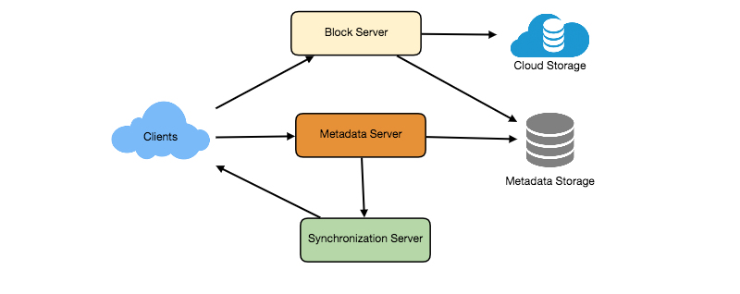
As shown in the diagram above, Block servers will work with the clients to upload/download files from cloud storage and Metadata servers will keep metadata of files updated in a SQL or NoSQL database. Synchronization servers will handle the workflow of notifying all clients about different changes for synchronization.

- Detailed Component design,
For detailed component design, see the following documents:
Components of Cloud File Storage.png

From these documents, it is evident that we have following major components in our system:
client, metadata database, synchronization service, message queuing service, cloud/block storage. We are going to discuss all these major components one by one.
  - Client,
The Client Application monitors the workspace folder on the user’s machine and syncs all files/folders in it with the remote Cloud Storage. The client application will work with the storage servers to upload, download, and modify actual files to backend Cloud Storage. The client also interacts with the remote Synchronization Service to handle any file metadata updates, e.g., change in the file name, size, modification date, etc.

Here are some of the essential operations for the client:
A) Upload and download files.
B) Detect file changes in the workspace folder.
C) Handle conflict due to offline or concurrent updates.

How do we handle file transfer efficiently? As mentioned above, we can break each file into smaller chunks so that we transfer only those chunks that are modified and not the whole file. Let’s say we divide each file into fixed sizes of 4MB chunks. We can statically calculate what could be an optimal chunk size based on 1) Storage devices we use in the cloud to optimize space utilization and input/output operations per second (IOPS) 2) Network bandwidth 3) Average file size in the storage etc. In our metadata, we should also keep a record of each file and the chunks that constitute it.

Should we keep a copy of metadata with Client? Keeping a local copy of metadata not only enable us to do offline updates but also saves a lot of round trips to update remote metadata.

How can clients efficiently listen to changes happening with other clients? One solution could be that the clients periodically check with the server if there are any changes. The problem with this approach is that we will have a delay in reflecting changes locally as clients will be checking for changes periodically compared to a server notifying whenever there is some change. If the client frequently checks the server for changes, it will not only be wasting bandwidth, as the server has to return an empty response most of the time, but will also be keeping the server busy. Pulling information in this manner is not scalable.
A solution to the above problem could be to use HTTP long polling. With long polling the client requests information from the server with the expectation that the server may not respond immediately. If the server has no new data for the client when the poll is received, instead of sending an empty response, the server holds the request open and waits for response information to become available. Once it does have new information, the server immediately sends an HTTP/S response to the client, completing the open HTTP/S Request. Upon receipt of the server response, the client can immediately issue another server request for future updates.

Based on the above considerations, we can divide our client into following four parts:
I. Internal Metadata Database will keep track of all the files, chunks, their versions, and their location in the file system.
II. Chunker will split the files into smaller pieces called chunks. It will also be responsible for reconstructing a file from its chunks. Our chunking algorithm will detect the parts of the files that have been modified by the user and only transfer those parts to the Cloud Storage; this will save us bandwidth and synchronization time.
III. Watcher will monitor the local workspace folders and notify the Indexer (discussed below) of any action performed by the users, e.g. when users create, delete, or update files or folders. Watcher also listens to any changes happening on other clients that are broadcasted by Synchronization service.
IV. Indexer will process the events received from the Watcher and update the internal metadata database with information about the chunks of the modified files. Once the chunks are successfully submitted/downloaded to the Cloud Storage, the Indexer will communicate with the remote Synchronization Service to broadcast changes to other clients and update remote metadata database.
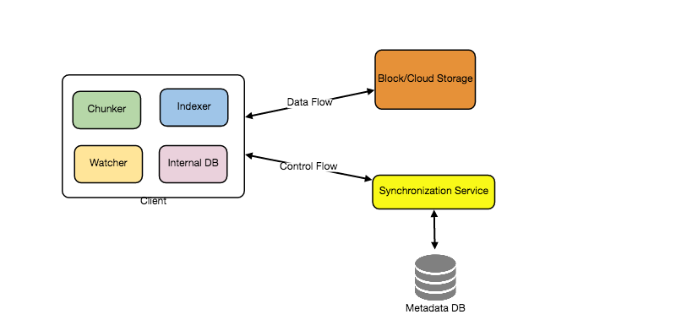

How should clients handle slow servers? Clients should exponentially back-off if the server is busy/not-responding. Meaning, if a server is too slow to respond, clients should delay their retries and this delay should increase exponentially.

Should mobile clients sync remote changes immediately? Unlike desktop or web clients, mobile clients usually sync on demand to save user’s bandwidth and space.
  - Metadata database,
The Metadata Database is responsible for maintaining the versioning and metadata information about files/chunks, users, and workspaces. The Metadata Database can be a relational database such as MySQL, or a NoSQL database service such as DynamoDB. Regardless of the type of the database, the Synchronization Service should be able to provide a consistent view of the files using a database, especially if more than one user is working with the same file simultaneously. Since NoSQL data stores do not support ACID properties in favor of scalability and performance, we need to incorporate the support for ACID properties programmatically in the logic of our Synchronization Service in case we opt for this kind of database. However, using a relational database can simplify the implementation of the Synchronization Service as they natively support ACID properties.
The metadata Database should be storing information about following objects:
    - Chunks
    - Files
    - User
    - Devices
    - Workspace (sync folders)
  - Synchronization Service,
The Synchronization Service is the component that processes file updates made by a client and applies these changes to other subscribed clients. It also synchronizes clients’ local databases with the information stored in the remote Metadata DB. The Synchronization Service is the most important part of the system architecture due to its critical role in managing the metadata and synchronizing users’ files. Desktop clients communicate with the Synchronization Service to either obtain updates from the Cloud Storage or send files and updates to the Cloud Storage and, potentially, other users. If a client was offline for a period, it polls the system for new updates as soon as they come online. When the Synchronization Service receives an update request, it checks with the Metadata Database for consistency and then proceeds with the update. Subsequently, a notification is sent to all subscribed users or devices to report the file update.
The Synchronization Service should be designed in such a way that it transmits less data between clients and the Cloud storage to achieve a better response time. To meet this design goal, the Synchronization Service can employ a differencing algorithm to reduce the amount of data that needs to be synchronized. Instead of transmitting entire files from clients to the server or vice versa, we can just transmit the difference between two versions of a file. Therefore, only the part of the file that has been changed is transmitted. This also decreases bandwidth consumption and cloud data storage for the end user. As described above, we will be dividing our files into 4MB chunks and will be transferring modified chunks only. Server and clients can calculate a hash (e.g., SHA-256) to see whether to update the local copy of a chunk or not. On the server, if we already have a chunk with a similar hash (even from another user), we don’t need to create another copy, we can use the same chunk. This is discussed in detail later under Data Deduplication.
To be able to provide an efficient and scalable synchronization protocol we can consider using a communication middleware between clients and the Synchronization Service. The messaging middleware should provide scalable message queuing and change notifications to support a high number of clients using pull or push strategies. This way, multiple Synchronization Service instances can receive requests from a global request Queue, and the communication middleware will be able to balance its load.
  - Message Queuing Service,
An important part of our architecture is a messaging middleware that should be able to handle a substantial number of requests. A scalable Message Queuing Service that supports asynchronous message-based communication between clients and the Synchronization Service best fits the requirements of our application. The Message Queuing Service supports asynchronous and loosely coupled message-based communication between distributed components of the system. The Message Queuing Service should be able to efficiently store any number of messages in a highly available, reliable and scalable queue.
The Message Queuing Service will implement two types of queues in our system. The Request Queue is a global queue and all clieents will share it. Clients’ requests to update the Metadata Database will be sent to the Request Queue first, from there the Synchronization Service will take it to update metadata. The Response Queues that correspond to individual subscribed clients are responsible for delivering the update messages to each client. Since a message will be deleted from the queue once received by a client, we need to create separate Response Queues for each subscribed client to share update messages.
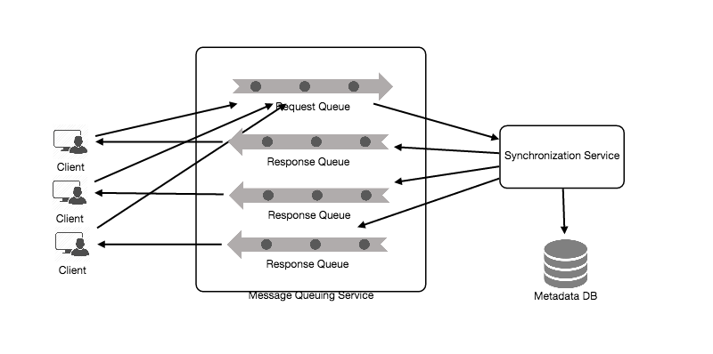
  - Cloud/Block Storage,
Cloud/Block Storage stores chunks of files uploaded by the users. Clients directly interact with the storage to send and receive objects from it. Separation of the metadata from storage enables us to use any storage either in the cloud or in-house.

How will this system be working (file processing workflow)?
The sequence below shows the interaction between the components of the application in a scenario when Client A updates a file that is shared with Client B and C, so they should receive the update too. If the other clients are not online at the time of the update, the Message Queuing Service keeps the update notifications in separate response queues for them until they come online later.
A) Client A uploads chunks to cloud storage.
B) Client A updates metadata and commits changes.
C) Client A gets confirmation and notifications are sent to Clients B and C about the changes.
D) Client B and C receive metadata changes and download updated chunks.
- Concurrency,
- Data Partitioning,
To scale out our DB, we need to come up with a partitioning scheme that would divide and store our data to different DB servers:
  - Vertical or feature based partitioning,
  - Range based partitioning,
We can store URLs in separate partitions based on the first letter of the URL or the hash key. Hence we save all the URLs starting with letter ‘A’ in one partition, save those that start with letter ‘B’ in another partition and so on. This approach is called range-based partitioning. We can even combine certain less frequently occurring letters into one database partition. We should come up with a static partitioning scheme so that we can always store/find a file in a predictable manner.
The main problem with this approach is that it can lead to unbalanced servers. For example: we decide to put all URLs starting with letter ‘E’ into a DB partition, but later we realize that we have too many URLs that start with letter ‘E’.
  - Hash based partitioning,
In this scheme, we take a hash of the object we are storing. We then calculate which partition to use based upon the hash. In our case, we can take the hash of the ‘key’ or the actual URL to determine the partition in which we store the data object.
Our hashing function will randomly distribute URLs into different partitions (e.g., our hashing function can always map any key to a number between [1…256]), and this number would represent the partition in which we store our object.
This approach can still lead to overloaded partitions, which can be solved by using Consistent Hashing during writing and reading of data. But in case of database we cannot (should not) use consistent hashing to shift data from one node to other in case of addition or removal of any node.
  - Sharding based on TinyUrl creation time is not possible here because we don’t search our tinyurls on the basis of creation time but on the basis of tinyurl so we can only tinyurl string here as the basis of partitioning.
  - a
- Service Component Partitioning,
  - Vertical or feature based partitioning,
  - Range based partitioning,
  - Hash based partitioning,
- Data replication,
To ensure the high availability, we need to have at least three replicas of every partition of the database. Among these three replicas, one will be the master (which will be used for all the writes and may also be used for reads) and the other two will be the slaves (both of which may be used for reads or we may keep one of them on hot-standby).
- Data archiving,
In this case we archive the older data by transferring it on some less expensive, low configuration database set up. When we get some read query, we will search our data in following way:
  - First search the data in cache and if it is found in cache, serve it,
  - If the data is not found in cache go to main database, get the data and update the data in the cache,
  - If the data is not found in main database as well, go to archive database, get the data and update the data in the cache,
  - If the data is not found even in arviches, return the not found status in the response.
This data archiving will involve:
A) writing of older data (say data older between one to two week) from our main database to the archive database,
B) verification of the written data that whether it is properly written or not and
C) if it is properly written on archive database cluster, then deletion of that older data (one week older to two week older) from our main database.
We run this archiving process on some schedule (say daily, weekly or monthly but neither too quickly nor not at all).
- Cache,
  - How much cache should we use?
We can start with 20% of daily traffic and, based on clients’ usage pattern, we can adjust how many cache servers we need. As estimated above, we need 170GB memory to cache 20% of daily traffic. Since a modern day server can have 256GB memory, we can easily fit all the cache into one machine. Alternatively, we can use a couple of smaller servers to store all these hot URLs.
  - Which cache eviction policy would best fit our needs?
LRU
  - How can each cache replica be updated?
Whenever there is a cache miss, our servers would be hitting a backend database. Whenever this happens, we can update the cache and pass the new entry to all the cache replicas. Each replica can update their cache by adding the new entry. If a replica already has that entry, it can simply ignore it.
- Fault Tolerance
The service is partitioned at all the components, there are multiple web servers, multiple application servers and multiple KGS as well. Our database is also partitioned on the basis of hash and every partition have master – slave configuration. So our service is fault tolerent at all the components.
- Where to add load balancers?
We can add a Load balancing layer at three places in our system:
  - Between Clients and web servers
  - Between Application Servers and database servers
  - Between Application Servers and Cache servers
- Purging or DB cleanup,
The expired links should be removed from our database (or mark them expired). If we chose to actively search for expired links to remove them, it would put a lot of pressure on our database. Instead, we can slowly remove expired links and do a lazy cleanup. Our service will make sure that only expired links will be deleted, although some expired links can live longer but will never be returned to users. Following ways can be used to cleanup the database:
  - Whenever a user tries to access an expired link, we can delete the link and return an error to the user.
  - A separate Cleanup service can run periodically to remove expired links from our storage and cache. This service should be very lightweight and can be scheduled to run only when the user traffic is expected to be low.
  - We can have a default expiration time for each link (e.g., two years).
  - After removing an expired link, we can put the key back in the key-DB to be reused.
- Data deduplication,
- Security,
- Optimizations on the client to improve user experience,
  - browser cache,
(leveraging the browser cache is crucial for assets that are rarely changing),
  - try to reduce the number of http requests,
  - minify javascript and css,
(minification of resources means removing unnecessary characters from your HTML, JavaScript, and CSS that are not required to load, such as: White space characters, New line characters, Comments, Block delimiters, etc),
  - avoid 301 redirects,
(Redirects are performance killers. Avoid them whenever possible.),
- User Persionalization,
- Advanced Issues,
- Deployment,
  - docker,
  - kubernete,
  - autoscaling,
  - all internal servers will be deployed on vpn,
- Analytics,
  - What type of analytics should be tracked and how that analytics will be used to extract informations?
    - Some statistics worth tracking: country of the visitor, date and time of access, web page that refers the click, browser or platform from where the page was accessed. These analytics data will be used to understand the trends and the behaviour of the population.
    - Since realtime analytics are not a requirement, we could simply MapReduce the Web Server logs to generate hit counts.
    - We should store both types of logs, i.e write logs as well as read logs.
    - As we are providing tinyUrl service, we will have very valuable logs of different types of service, on which we can run analytics to know many things.
    - Write logs can be analysed to undertand that which service is using our service more and from what area we are getting more hits. If required, we can add our write server also for that region.
    - Read logs can be analysed to understand the trends and popularity of a service, behaviour and likes and dislikes of the people, etc geographical region wise, age group wise, rural-urban wise and so on.
    - We can also know about number of hits from areas and we can take decision to increase or decrease number of CDNs in that area.
- Monitoring: Having the ability to monitor our systems is crucial. We should constantly collect data to get an instant insight into how our system is doing. We can collect following metrics/counters to get an understanding of the performance of our service:
  - No. of hits per day,
  - No. of hits per second and what is the daily peak?
  - Amount of data coming in and going out per day,
  - Amount of data coming in and going out per second and what is the daily peak?
  - Average latency seen by the user,

By monitoring these counters, we will realize if we need more replication or load balancing or caching, etc.
Continue benchmarking and monitoring your system to address bottlenecks as they come up. Scaling is an iterative process.
- Follow up questions:
  - What will you do if say 10 people try to generate same long url.
Answer: We won’t generate 10 tinyurls for same long url but the same tinyurl will be provided to all the later 9 people.
  - Assume that your client is a famous blogger and the total number of hits- 10 Lakhs Hits per Day. How will you fit your design for this scale?
Answer: Our architecture can easily handle that much amount of traffic. No issues. And even if our architecture is not able to handle that much load, then our architecture is horizontally scalable so we can scale it easily.
  - Can users create private URLs or allow a particular set of users to access a URL?
Answer: To manage this, we need following things in our system:
    - we need login and authentication in our system.
    - Now access of tinyUrls to limited users can be implemented in many different ways:
      - Using password: A registered user will also send a password in the createTinyUrl API which will be stored in the database table as follows:
tinyurlLongurlMapTable(tinyUrl, longUrl, encryptedTinyUrlPassword, long expirationTime)
And the registered user can share that password with any set of user and any registered user who will send the get request with the correct password, that user only can get the corresponding long url.
Store the data of private user in different table and not in the same table as encryptedTinyUrlPassword will not be available for public users and if the data of public users is too large as compared to the data of private users, then it can save a lot of space.
      - A user can create readPermissionUserSet: In this type of implementation, a user will be able to create and save different readPermissionUserSets (such as userSet1, userSet2, etc.) for his account. And the user will also send the userSet in the createTinyUrl API and if that userSet will be valid, then it will be saved into the database table as follows:
tinyurlLongurlMapTable(tinyUrl, longUrl, readPermissionUserSet, long expirationTime)
Now if any registerd user will ask for longUrl for any shortUrl through the readAPI, then we will first check that whether this user is permitted to read this tinyUrl or not.
Store the data of private user in different table and not in the same table as readPermissionUserSet will not be available for public users and if the data of public users is too large as compared to the data of private users, then it can save a lot of space.

  - Let us assume that your firm got famous and a new client came in, and the client is asking you for 10 Crore Hits per day. And your firm started charging in the following way:
    - First 10K Hits/day – Free
    - 10K Hits/Day -- 1 Paise/Hit
Answer: Billing can be done using analytics data as we are storing every hit with many informations such as geolocation of the user, source website, etc. We cant increase the hitCount for tinyUrl for every hit directly from the read API into the database because if we do so, it will vanish the very purpose of cache as the cache is maintained only to reduce the latency. If will start updating database on every read hit, then there will not remain any benefit of cache. It can be updated through a message broker consumer. But still I think that it is better to extract or maintain the data for billing into the analytics database because the primary database is for read and write and not for billing or any other thing.
  - Suppose the new client of above question demands tinyUrl update functionality also. To provide update functionality also, how the design will change?
Answer: If we want to provide update functionality also for the registered users, then the write api will also connect to the cache service through LB and an update response will only be returned true the stale cache value will be invalidated or deleted and if its value in DB will be changed.

Pastebin:
- Block storage (object store) datastore will also be used in case of Pastebin. In case of pastebin, we will store the data to be pasted on some object store and will store its path in place of longurl of tinyurl service.
- In case of pastebin, there should be a limit on the size of data (say 10 MB) which can be pasted once to get a tinyurl for that.

